**xFPT ACADEMY INTERNATIONAL**



**FPT – APTECH COMPUTER EDUCATION**

**Shrek Juice**

|  |  |  |  |
| --- | --- | --- | --- |
| **Center Name:** | FPT – Aptech – HCM2 | | |
|  | Address:590 Cach Mang Thang Tam,  District 3, Ho Chi Minh City | | |
| **Instructor:** | Ms. Le Mong Thuy | | |
|  |  | | |
| **Class:** | T1.2010.E0 | | |
| **Group:** | 01 | | |
| **Group members** | **Name** | | **Student ID** | |
|  | Nguyễn Lê Trường | | Student1280929 | |
|  | Bùi Thị Thanh Phương | | Student1280945 | |
|  | Đinh Thành Bảo Nam | | Student1280928 | |
| **Project Duration** | Start date | 25th DEC 2020 | | |
|  | End date | 26th JAN 2021 | | |

**This is to certify that**

#### **Mr.:**

NGUYEN LE TRUONG

Đinh Thành Bảo Nam

#### **Ms.:**

BUI THI THANH PHUONG

**has successfully designed & developed**

## eProject: SHERK JUICE

**Submitted by:**

NGUYEN LE TRUONG

**Date of issue:** JAN 06th 2021

**Authorized Signature:**

TABLE OF CONTENTS

eProject: SHERK JUICE 2

ACKNOWLEDGEMENT 4

SYNOPSIS 4

PROBLEM STATEMENT 5

CUSTOMER'S REQUIREMENTS SPECIFICATIONS (CRS) 6

Scope of the work (in brief): 7

Architecture and design of the system: 8

Diagram of the web site: 9

TASK SHEET REVIEW 1 10

SITE MAP 11

MOCK OF THE WEBSITE 12

TASK SHEET REVIEW 2 15

# ACKNOWLEDGEMENT

The success of the assignment requires lots of guidance and assistance from many people and we are extremely fortunate to have all these elements all along with the completion of project.

First of all, we are here to sincerely thank Ms. Le Mong Thuy for continuous support and supervision whenever we need. That gives us tremendous confidence to move toward achieving the goal.

Next, I appreciate for great enthusiasm showed from all team members that makes project rolls smoothly with plenty of fun. Team contributions and participations have indeed paid off.

Above all, experience learned throughout working on the project will surely become valuable and useful assets to all of us.

# SYNOPSIS

Shrek-Juice.com is a website of the Shrek Juice Centre which is big Juice Centre

famous for variety of juices it provides. It also provides catering service for various

events like Wedding, Shows and so on.

Shrek-Juice.com provides detail of each drink it produces. All of the information is well organized and placed into associated categories for customers to easily search for.

For continuous improvements on future service and product provided, customer feedback is constantly monitored and quickly responded at earliest convenience.

# PROBLEM STATEMENT

To make website becomes catchier and more user friendly along with new type of juices, we realized there surely has something needed to be improved for better user experience.

Below are the guidelines that serve as requirements for web site to be created based on.

1. The Home Page should be created making use of Sections with a suitable logo.
2. Few tips can be included in the blank space area of the webpage.
3. The Menus must be included in the website.
4. Links such as
   1. Products and Menu
      1. Fruit juices
      2. Vegetable Juices
      3. Smoothies
      4. Protein Shakes
      5. Winter Menu
      6. Chocolate Juices
      7. Mock Tails
   2. Store Location
   3. Franchising
   4. Catering
   5. Feedback
   6. About us
5. There should be a “Contact Us” page which will have the Address of the

Company which should be displayed using GeoLocation API (eg. GoogleMaps)

and the email address which when clicked will invoke the local mail client

from where they can send an email.

1. Feedback must be taken on the information available on website.

# CUSTOMER'S REQUIREMENTS SPECIFICATIONS (CRS)

**CLIENT**: **Shrek-Juice website**

**Business / Project objective:**

Provide customers pleasant shopping experience with clear juice information displayed at the same time. Ensure users can easily search and find information needed. Also establish good communication channel between customers and shop.

**Input to the system:**

* Sections from different categories (navigation menu)
* Enter the name of specific type of juice to search
* Users’ feedback

**Output from the system:**

* Detailed information about the specific juice with price as well as illustrated pictures
* Display of product menu
* Display of special events/occasions that shop organizes
* Display of shop history, philosophy
* Search results.
* Display locations of the shops and provide information about transportation to the place
* Display contact information and approaches (email, FB, etc..)

**Hardware/ Software Requirements**

**Hardware**

* Intel Pentium 4 processor or higher (Developer/User)
* 1 Gigabytes of RAM or higher (Developer)
* 512 Megabytes of RAM or higher (Web User)

**Software**

* Windows 7 OS or higher (Developer)
* Windows XP OS or higher (Web User)
* Web browsers such as IE, Chrome or Firefox are supporting HTML5, CSS3 and JavaScript. (Developer/User)

# Scope of the work (in brief):

With the consent of the team, below lists the conclusion of requirements that needs to be implemented into website:

1. New design of Shrek-Juice logo and place on left upper side
2. Navigation bar contains 5 categories (Home, About, Founder, Menu, Contact)
3. Click on each category will navigate to associated page on home page
4. Home page shows shop story with captions together with image
5. Home page shows season special juices with product information when mouse hovered over
6. Home page shows feedback with 3 selections for users to select
7. Home page lists founders’ information with photo
8. Home pages provides contact function with map displayed, store information

# Architecture and design of the system:

 

Customer Windows platform devices

HTML, CSS, Jquery, Bootstrap, JavaScript



Wed sever

# Diagram of the web site:

# 

**Home**

**About**

# TASK SHEET REVIEW 1

End

**Contact**

**Menu**

**Foder**

|  |  |  |  |  |  |  |  |
| --- | --- | --- | --- | --- | --- | --- | --- |
| **Project Ref. No.: eP/Advertisement Portal Management System/01** | | **Project Name** | **Activity Plan Prepared By** | **Date of Preparation of Activity Plan:** | | | |
| **Sr./No.** | **Task** | **Actual Start Date** | **Actual Days** | **Team member name** | **Status** |
| 1 | Problem statement | Shrek-Juice | Truong | 28-DEC-20 | 1 | Truong | Completed |
| 2 | Analysis of  Shrek-Juice website requirements  The scope of the work | 28-DEC-20 | 2 | Truong,Phuong | Completed |
| 3 | The scope of the work (in brief) | 28-DEC-20 | 2 | Truong,Nam | Completed |
| 4 | Architecture and design of the system | 28-DEC-20 | 2 | Phuong,Nam | Completed |
| 5 | Diagram of the website | 28-DEC-20 | 3 | Truong,Phuong,Nam | Completed |
| 6 | Task sheet | 28-DEC-20 | 2 | Truong | Completed |

|  |  |
| --- | --- |
| **Date:** | |
| Signature of Instructor:  **Ms. Le Mong Thuy** | Signature of Team Leader:  **Nguyen Le Truong** |

# SITE MAP

MENU

CONTACT US

FOUNDER

ABOUT

HOME

Peach Tea

Mock Tail

Strawberry Smoothie

Orange Juice

Veggie Juice

Chocolate

About us

Truong

Phuong

Nam

Feedback

Contact us

Find us

Reservation

Open hours

# MOCK OF THE WEBSITE

1) Homepage:

Navigation Menu

LOGO

Pictures Slideshow

Detail

Info

Detail

Info

Detail

Info

Image

Image

Member

Member

Image

Member

Footer

Image

Captions

2) Menu Page:

Navigation Menu

LOGO

Paragraph

Paragraph

Paragraph

Paragraph

Paragraph

Paragraph

Gallery

Gallery

Gallery

Gallery

Gallery

Gallery

Footer

Pictures Slideshow

3) Contact Page:

Navigation Menu

LOGO

g

Caption

Caption

Caption

Command

Map

Title

Footer

# TASK SHEET REVIEW 2

# TASK SHEET REVIEW 2

|  |  |  |  |  |  |  |  |
| --- | --- | --- | --- | --- | --- | --- | --- |
| **Project Ref. No.: eP/Advertisement Portal Management System/01** | | **Project Name** | **Activity Plan Prepared By** | **Date of Preparation of Activity Plan:** | | | |
| **Sr./No.** | **Task** | **Actual Start Date** | **Actual Days** | **Team member name** | **Status** |
| 1 | Site map | Shrek-Juice | Truong | 04-Jan-21 | 1 | Truong | Completed |
| 2 | Mock of website | 04-Jan-21 | 1 | Phuong | Completed |
| 3 | Task Sheet | 04-Jan-21 | 1 | Nam | Completed |

|  |  |
| --- | --- |
| **Date:** | |
| Signature of Instructor:  **Ms. Le Mong Thuy** | Signature of Team Leader:  **Nguyen Le Truong** |

**WEBSITE DESCRIPTION**

**1. Home page**

A description

This website displays the following information: Displays the site name and logo, images, home, about, menu, contact and number contact.

b) Screenshot

|  |
| --- |
|  |

**Navigation bar**

**Description**

This menu bar allows users to navigate to all web pages of the entire site such as the home page, about, menu, contact and number contact.

**2. About**

**1. Description:**  
Display about shrek-Juice story.

**2. Screenshot:**

|  |
| --- |
|  |

**3.Menu**

**1. Description:**

Displays pictures and information products and menu of below screenshot

-Fruit juices

-Vegetable juices

-Smoothies

-Protein Shakes

-Winter menu

-Chocolate Juices

-Mock Tails

**2. Screenshot:**

|  |  |
| --- | --- |
|  |  |

**4.FEEDBACK:**

**1. Description:**

Help users enter information and comments about the site

**2. Screenshot:**

|  |
| --- |
|  |

## 5.Contact Us

**1. Description:**

Contact Us page ,the Address of the Company which should be displayed using GeoLocation API and the email address which when clicked will invoke the local mail client from where they can send an email.

**2. Screenshot:**

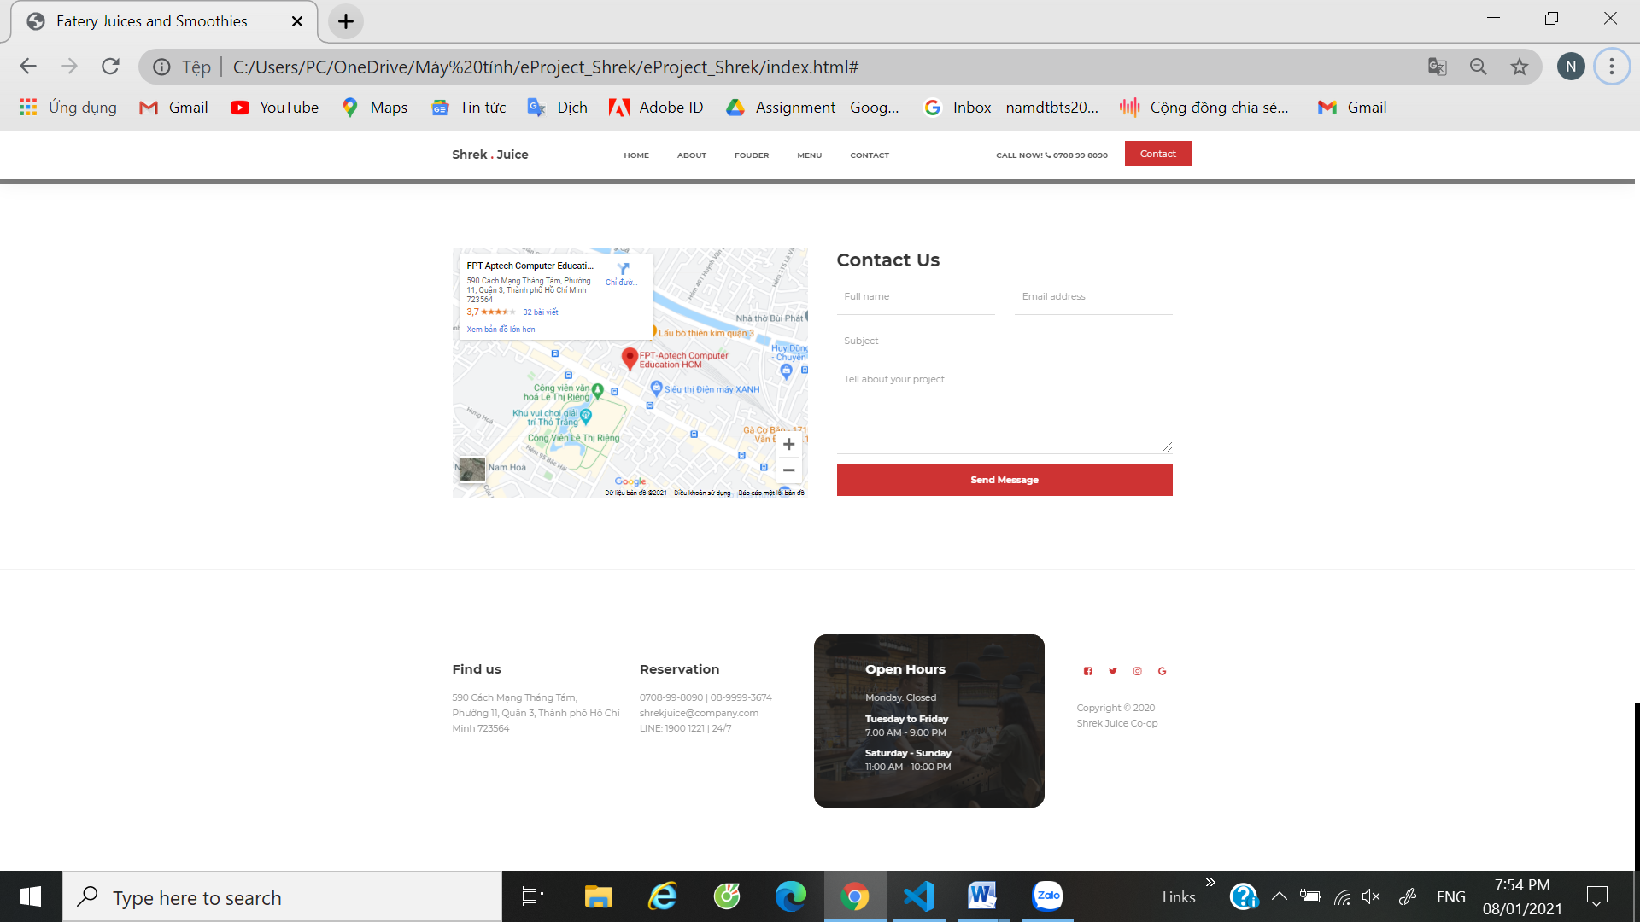

# TASK SHEET REVIEW 3

|  |  |  |  |  |  |  |  |
| --- | --- | --- | --- | --- | --- | --- | --- |
| **Project Ref. No.: eP/Advertisement Portal Management System/01** | | **Project Name** | **Activity Plan Prepared By** | **Date of Preparation of Activity Plan:** | | | |
| **Sr./No.** | **Task** | **Actual Start Date** | **Actual Days** | **Team member name** | **Status** |
| 1 | HOME PAGE | shrek-Juice | Truong | 11-Jan-21 | 1 | Truong | Completed |
| 2 | ABOUT | 11-Jan-21 | 1 | Truong | Completed |
| 3 | MENU | 11-Jan-21 | 1 | Truong, Nam | Completed |
| 4 | FEEDBACK | 11-Jan-21 | 1 | Nam, Phuong | Completed |
| 5 | CONTACT US |  |  | 11-Jan-21 | 1 | Phuong, Truong | Completed |

|  |  |
| --- | --- |
| **Date:** | |
| Signature of Instructor:  **Ms. Le Mong Thuy** | Signature of Team Leader:  **Nguyen Le Truong** |